**First BST Homework – Make a BST more useful by storing information**

* Start with my project code.
* Add the 4 labels, 4 textboxes, and 2 buttons to your form.
* Set their name properties and their displayed text
* double click the 2 buttons to create the methods

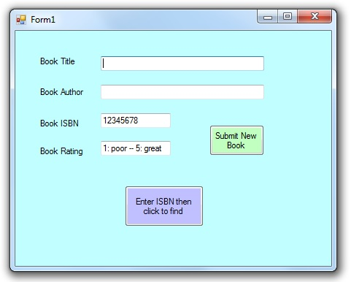

* For this exercise, consider the BST "key" and the ISBN value as one in the same. The Form code will think of it as an ISBN value, but the BST will use that value as the BST key.
* Add another class file named Book.cs
  + Define a Book class that holds the 3 properties you need to store for each book from the form
  + Define a Book constructor that takes no arguments, but sets
    - Title to "No Such Book"
    - Author to an empty string , which is just ""
    - Rating to 0
    - (The ISBN in the form becomes the BST key value, and is not stored in the Book object)
  + (We will use this as our default Book when the user asks for a book that we can't find.)
* Now modify your BST class and methods such that
  + your class BSTnode constructor takes in and stores a Book object in the new node
  + your public void Add(int keyParam) method takes in both a key(ISBN) and a Book object
  + your public bool Find(int targetKey) method returns a Book object
    - if there is no such book, it returns the default Book with the error message in the Title
    - if there is the book, it returns the book object found in the found node
* Now write the code in your two form button methods so:
  + when user clicks Submit New Book, you code creates a new Book object, sets its properties, and submits the book into your BST object (clear the 4 textboxes after the submit
  + when a user clicks the Find button, you use the ISBN field, call your BST class to find that object, get the book object back, and use its values to fill in the other 3 textboxes
* Test your project with at least 3 books.